1. Logical View
   1. Class Diagram

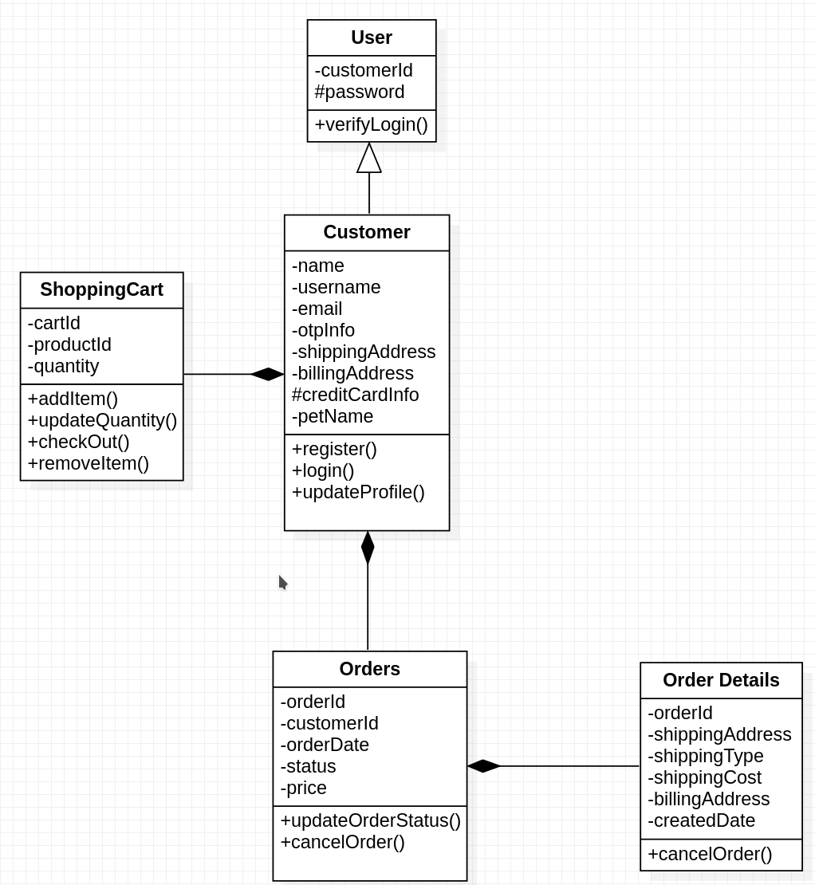

1. Process View
   1. Sequence Diagram
      1. 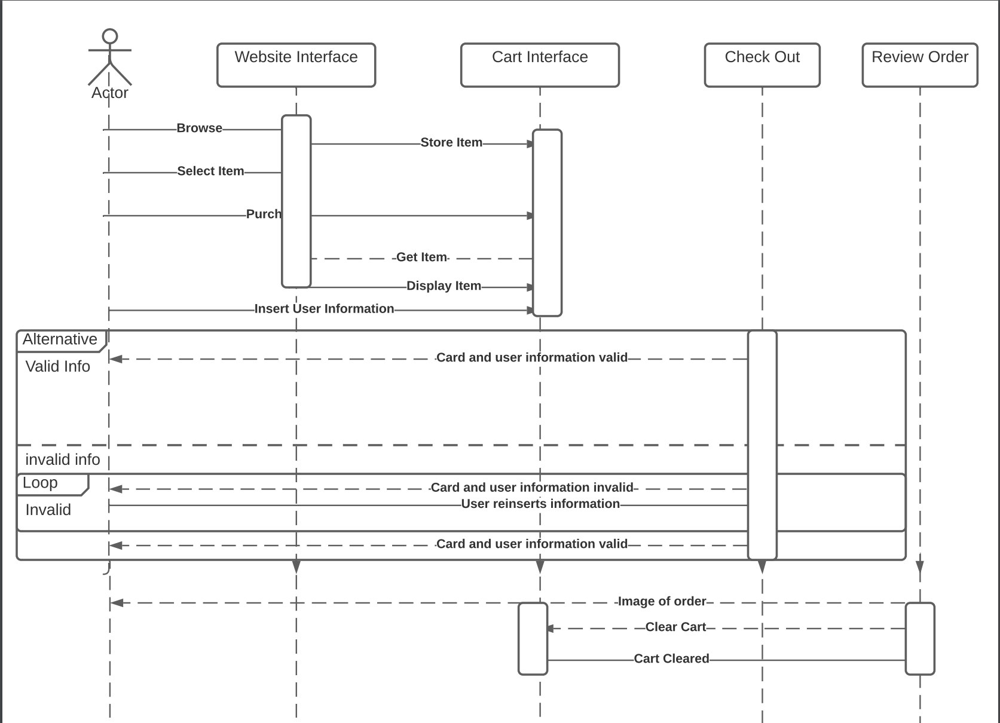
2. Development View
   1. Activity Diagram 1

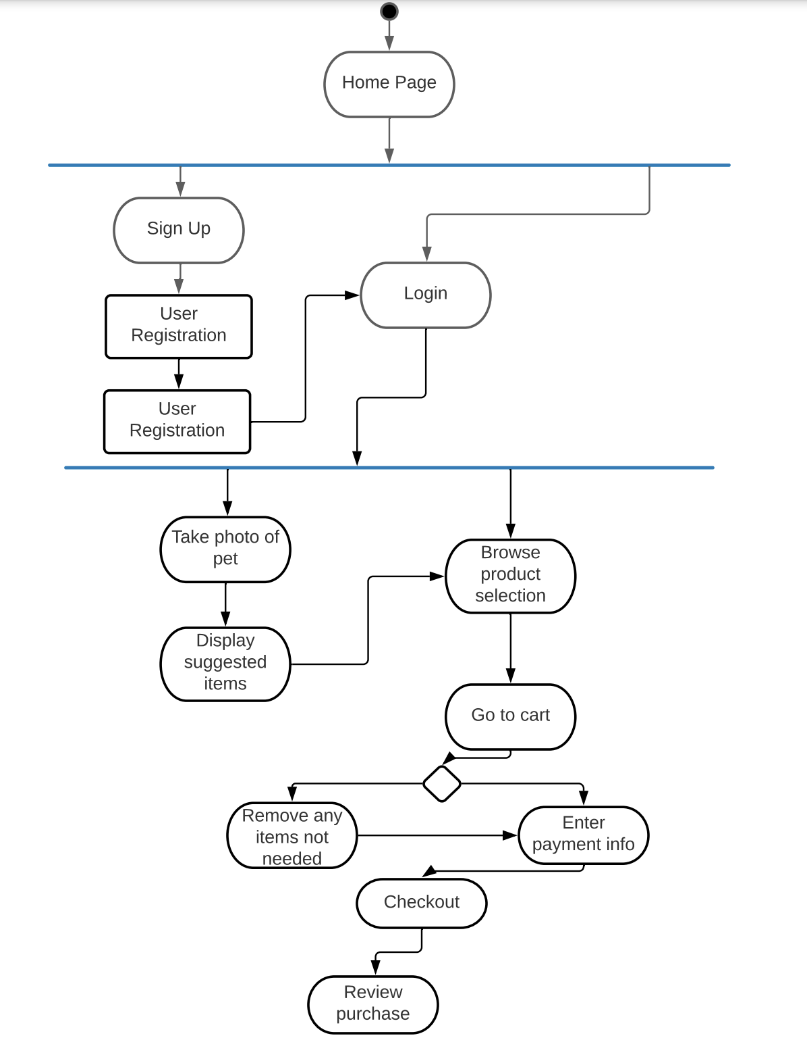

* 1. Package Diagram

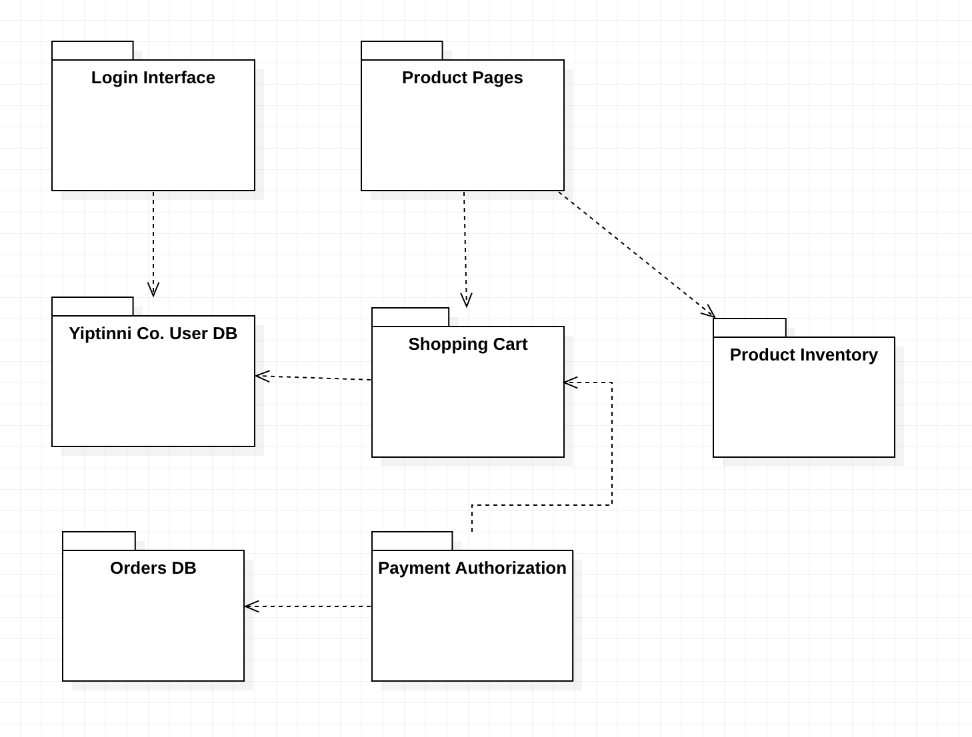

1. Physical View
   1. Deployment Diagram
      1. 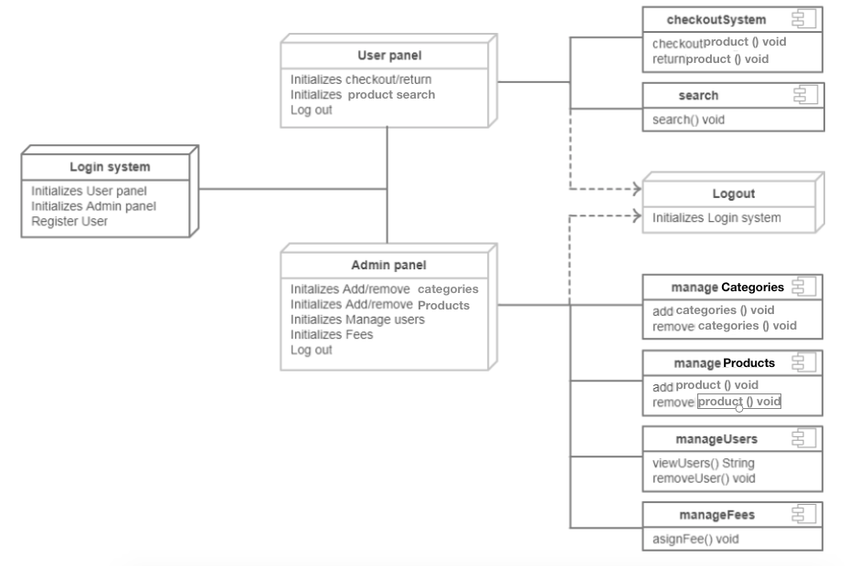
   2. Network Topology
      1. 